Visualizing your data with MongoDB Compass

* Visualize, understand, and work with your data through an intuitive GUI.
* Modify your data with a powerful visual editing tool.
* Understand performance issues with visual explain plans, view utilization and manage your indices.
* Know your data with built-in schema visualization
* Get immediate insight into server status and query performance
* Visualize, understand, and work with your geospatial data

**Getting started with Compass:**

Follow the steps to analyze the data using MongDB

**Step 1**:Connect to compass by entering the local host name in the given field “Hostname”

**(Note: To find the Hostname type command: “hostname” in command prompt )**

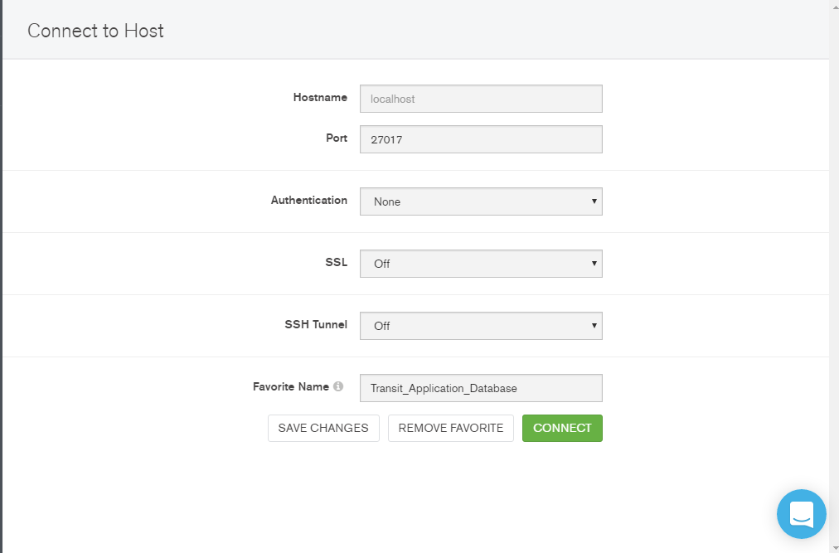

**Step 2:**

Once connected you can visualize the databases,collections,documents in the the

Compass.

**Exploring Transit Application Database using MongoDB Compass**

**This Screenshot shows the GeoSpatial Index with location Coordinates**

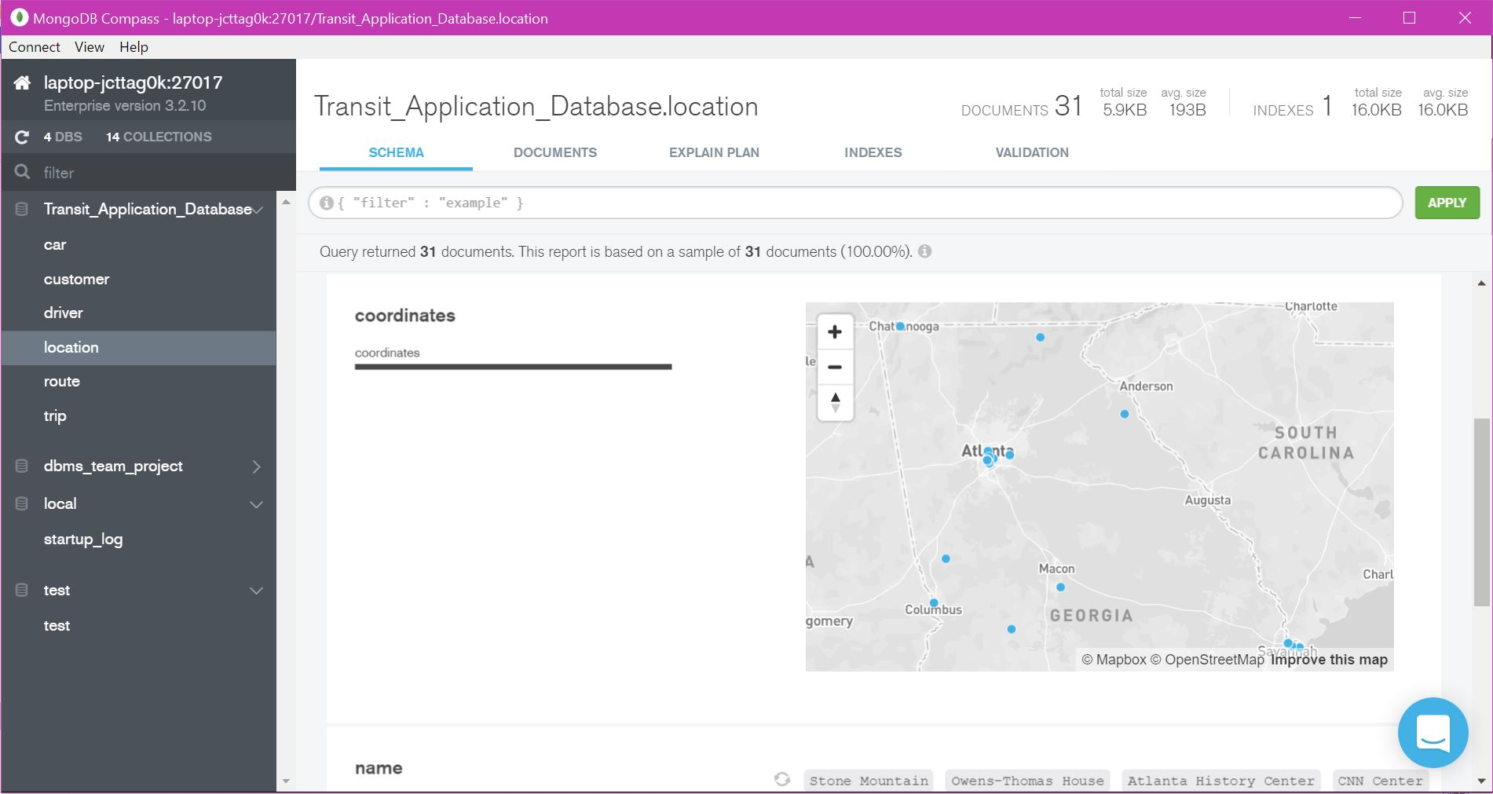

**There are two indexes ie. Default index, Geospatial Index in Location.**

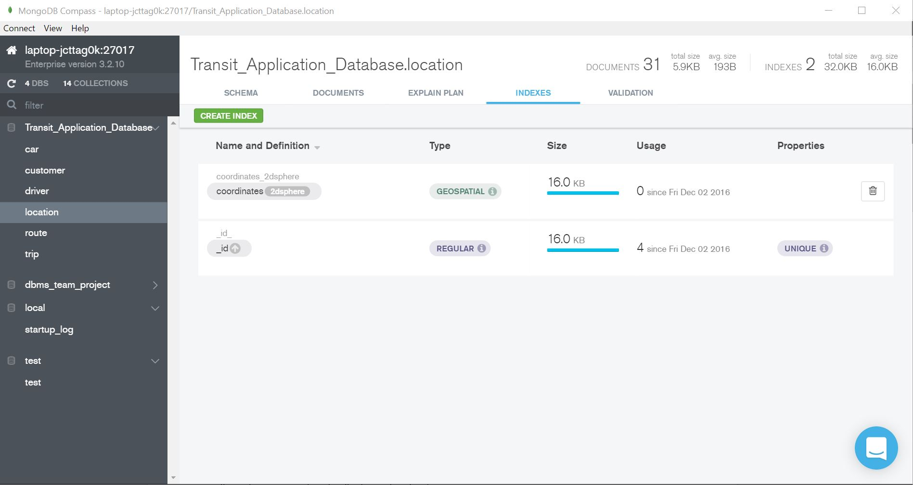

**Analyze the query using Query Performance Summary**

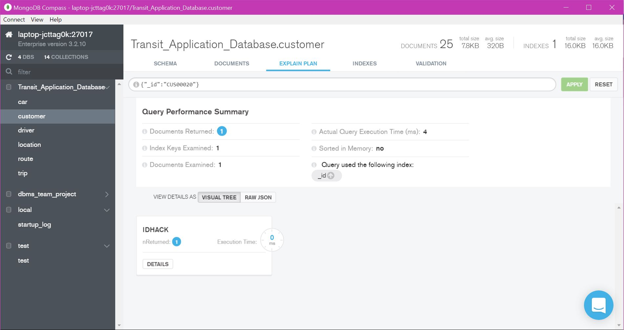

**Customer collections embedded with one –one Relationship**

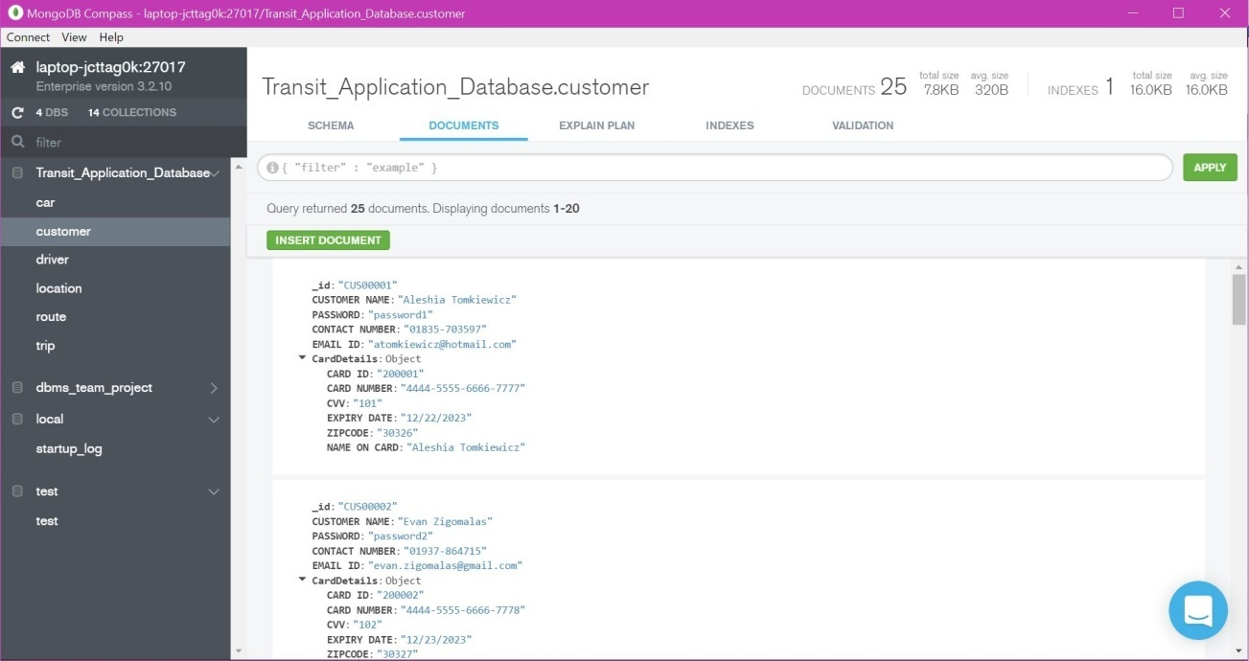

**Summary of Collections in the database**

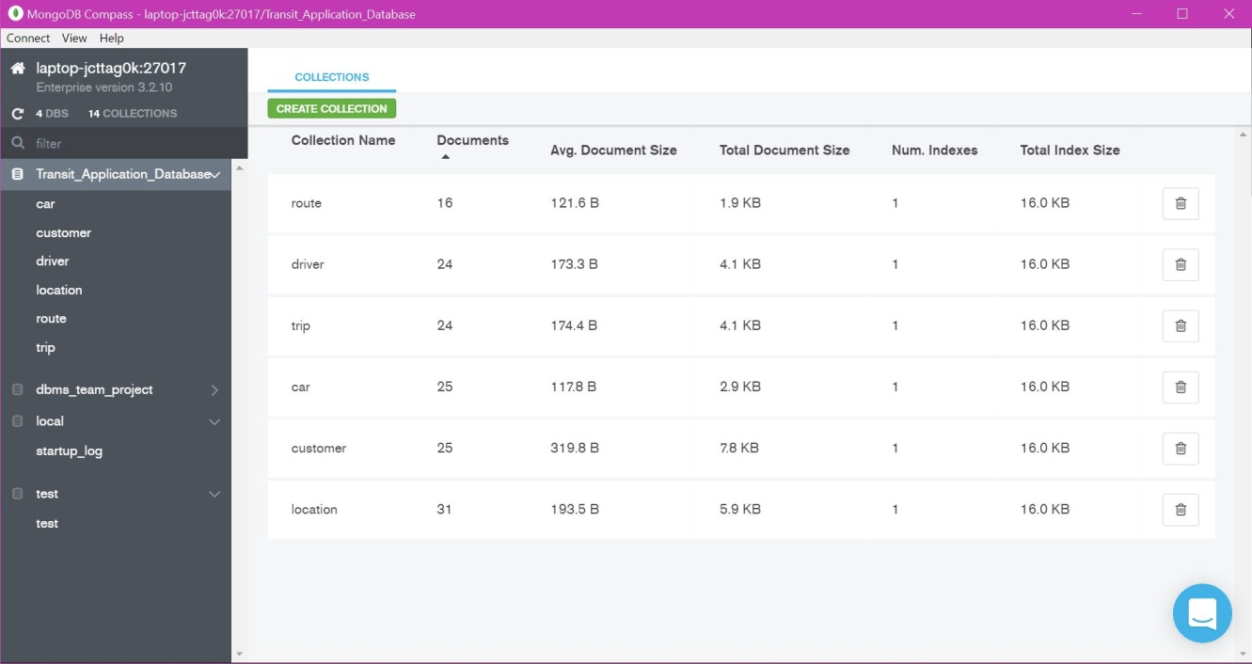

**Creation of rule/constraint directly from the GUI**

